**Money Transfer System**

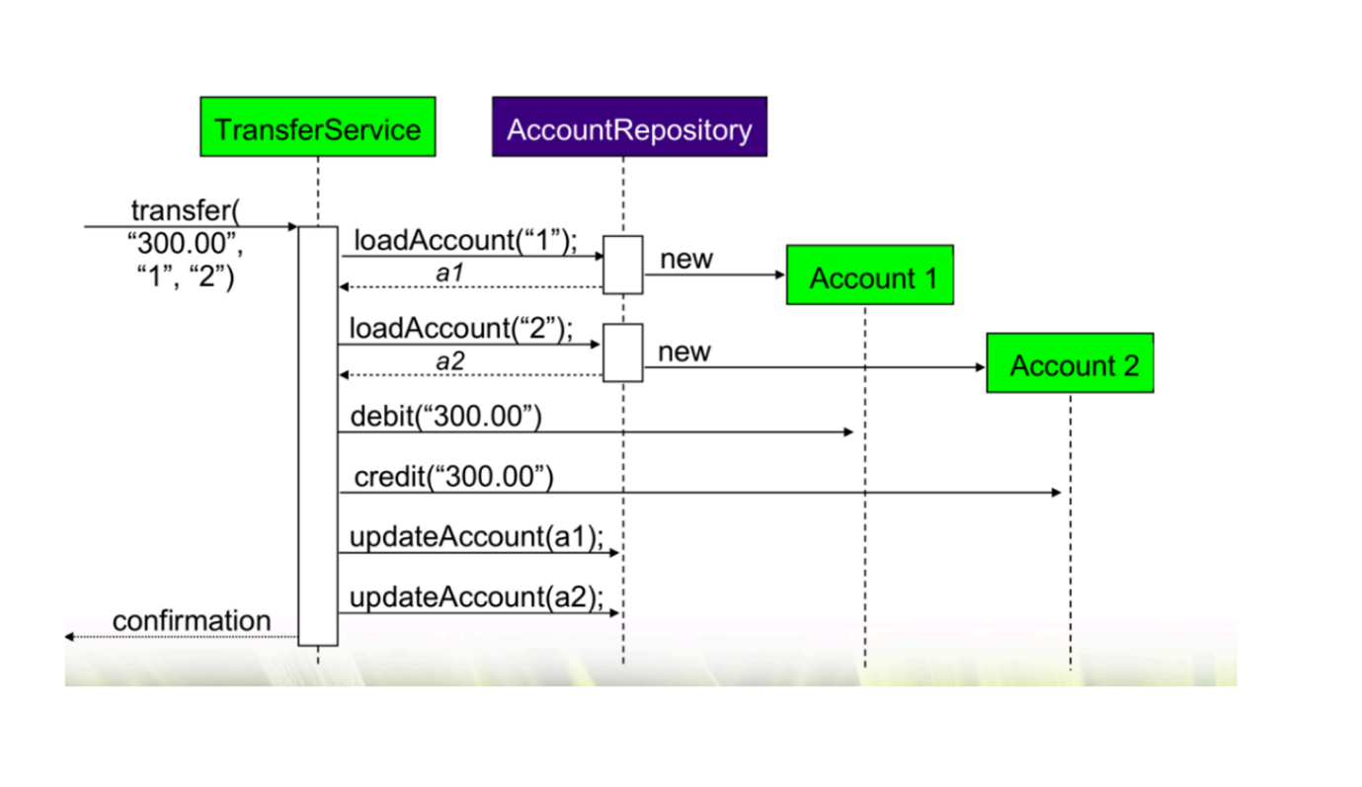

Problem Statement: Money-Transfer-System (MTS) to transfer amount between Account(s).

* After Login, we must show bank-dashboard screen
* Design UI for ‘Transfer’ and ‘Statement’ modules
* To Initiate Transfer, user must select from & to accounts and enter amount.
* Customer can view
  + Top 10 Transaction
  + Current month Transactions
  + Last 1 or 3 month Transactions
  + Between date range

Transactions statement can be viewed as HTML-view, PDF or Excel representations Note : PDF or Excel conversion should happen on browser-side only